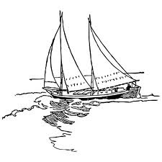
Regular Meeting Agenda for Thursday, July 20, 2012
Meeting location: upstairs at Lafayette

Welcome & Call to Order, 7pm
Civility Checklist
Additions to Agenda under new business
Secretary’s report from 6/21/2012, Sheryl Robins
Treasurer’s report, Al Robins

Communications read aloud:
Park Point 5-Miler details from race organizer

Committee Reports:
Sunshine Committee--update from L. Rutherford on the neighborhood welcome letter
Hospitality Committee
Program Committee-prospective Park Point “How To” projects-Rory Strange
Watch Committee
Art Fair Committee
The Breeze Committee
Youth Committee
Environmental Committee
Rummage Sale Committee

Discussion and Action on Unfinished Business:
Art Fair – reflections on the event, thoughts for next year
Fire Hall closure and new services since closure; Surf Rescue Seminar
Reimbursement for 3 new tables for rental business- will require 2 votes. Amount = $257.32. This will be the second vote to authorize reimbursement.

Discussion and Action on New Business:
Neighborhood Night Out sponsored by Lafayette Edible Community Garden, Coral M.
Communications from PPCC- email address corrections & collection of email addresses for PP business/info distribution only
Creation of ad hoc facilities committee

Review of Actions Taken
Adjourn

