Déjà vu: Dealing with High Water on Lake Superior, Again

Precipitation creating higher-than-average water levels across the Great Lakes has stirred more than sediment since 2015. Storms and the water they dropped have cost millions in damage and changed coastal ecosystems. The extra water has coastal residents, communities and industries asking questions of Minnesota Sea Grant staff: “Why is the water rising? What can we do about it?”
This is not the first time Lake Superior gained volume. Odds are it won’t be the last. Tom Beery, Minnesota Sea Grant’s resiliency specialist, talked with some coastal property owners in autumn 2018. The results of those discussions are spurring a team of regional environmental professionals, including staff from Minnesota Sea Grant, the Minnesota Department of Natural Resources Lake Superior Coastal Program and the Lake Superior National Estuarine Research Reserve, to develop strategies to help coastal communities cope with rising lake levels. In the meantime, for those who live, work and recreate along Minnesota’s Lake Superior coastline, here are five facts about Lake Superior’s fluctuating waterline and ideas for bracing for high water.

5 Facts:
Range of Recorded Great Lakes Water Levels
Source: USACE-Detroit District
 | Superior | Michigan-Huron | Erie | Ontario
Range (feet)  Range (meters) | 3.9  1.2 | 5.3  1.6 | 6.0  1.8 | 6.8  2.0
- The level of Lake Superior fluctuates less than those of the other Laurentian Great Lakes.
- Lake Superior's water level has hovered around an impressively narrow range for several centuries. Precipitation, evaporation and outflow drive the level of Lake Superior. Annual cycles also influence it as does wind and
Lake Superior Water Budget
barometric pressure.
- Minnesota Sea Grant Director John Downing is working to refine our understanding Lake Superior’s water budget. These pie charts offer a sense of the comings and goings of water in Lake Superior.
- The International Joint Commission and its associated International Lake Superior Board of Control have little effect on Lake Superior’s water level. Fluctuations are natural and should be expected. The Board regulates
outflows through Plan 2012. See the
IJC’s frequently asked questions for more details.

- Lake Superior reached its highest recorded level in October 1985 at 603.38 feet (183.91 meters) above sea level. Go to NOAA’s Great Lakes Level Dashboard to see Superior’s current level. (Government shut down? See U.S. Army Corps of Engineers information.

Winds produce storm surges and seiches that can visibly change water levels. For example, the NOAA water level gauge in Duluth hit its all-time high on October 10, 2018, when a storm surge pushed water 604.24 feet (184.17 meters) above sea level. The gage has been operating since April 1, 1860.

Sharon Moen

NOAA Water Level Gage

Duluth, MN - Station ID: 9099064
Established: April 1, 1860

Bracing for High Water:

- Learn the latest on shoreline stabilization from University of Minnesota Extension.
- Work with neighbors. For inspiration, read about Lake Ontario neighbors that designed shoreline protection, got government approval, pooled money, found a quarry to sell them 2,000 tons of stone, a trucking company to deliver it and contractors to build a revetment to rob waves of their energy.
- Understand the Minnesota Department of Natural Resources regulations for shoreline property owners.
- Slow the exodus of stormwater from land with green-infrastructure guidance from the U.S. Environmental Protection Agency.
- Consider purchasing national flood insurance. As the Federal Emergency Management Agency (FEMA) puts it, the National Flood Insurance Program aims to reduce the impact of flooding on private and public structures by providing affordable insurance to property owners, renters and businesses and by encouraging communities to adopt and enforce floodplain management regulations.
- Bone up on how the International Joint Commission makes decisions and how you can interact with them through public forums, webinars, Facebook and Twitter.
- Read about a study regarding the high waters of 1985 that Minnesota Sea Grant helped facilitate.
- Refrain from building near the Lake Superior shoreline. Minnesota Sea Grant specialists and researchers estimated erosion rates from Duluth to Grand Portage could exceed 15 meters over 5 years.
- Become Great Lakes climate ready with NOAA training.
- Organize post-storm beach clean-ups to reduce garbage on shorelines. Reminder: logs and vegetation that wash ashore can help shoreland stability.

- If you are the captain of a vessel, recognize that high water on Lake Superior negates some submerged obstacles but creates others. It can also produce unusual currents and increase the risk of causing wakes that could damage shorelines. Be aware of the risks associated with high water levels:
  - There could be newly submerged obstacles that can damage hulls and machinery.
  - Fixed objects like breakwaters, seawall and docks might be hiding underwater. Many new hazards are not marked with buoys.
  - Navigation buoys might have drifted out of position. If you encounter a stray buoy, transmit a safety notice to the U.S. Coast Guard.
See what a small change in water level means to the shoreline along Park Point Beach in Duluth, Minnesota, through NOAA’s Lake Level Viewer.
For the latest information on how Minnesota Sea Grant is working with industries and communities to adapt to changing water levels, contact Jesse Schomberg, Coastal Communities and Land Use Planning Extension Educator, jschombe@umn.edu, (218) 726-6182.

Lake Superior is Not Alone - Lake Levels Fluctuate

Great Lakes water levels 2005 - 2018.
source: NOAA Great Lake Water Level Dashboard

- Superior’s recent low
- 2007 October rains raised the lake over 6 inches in a month
- 2012 Solstice Flood and following rains raised the lake 9.5 inches in two months
- 2013 rains raised the lake 13.5 inches in two months
- 2017 rains raised the lake over 15 inches from April to September, creating a recent high
- 2018 rains raised the lake 5 inches from June 13-July 13
- 2017 exceptionally high water in Lake Ontario damages coastal communities

Recorded Ranges of Two Inland Lakes in Minnesota
Lake Pokegama, Pine City
Recorded range: 8.5 ft

Lake Minnetonka, Minnetonka
Recorded range: 9.33 ft

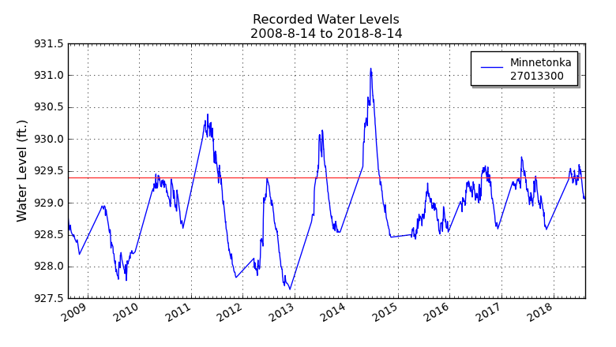
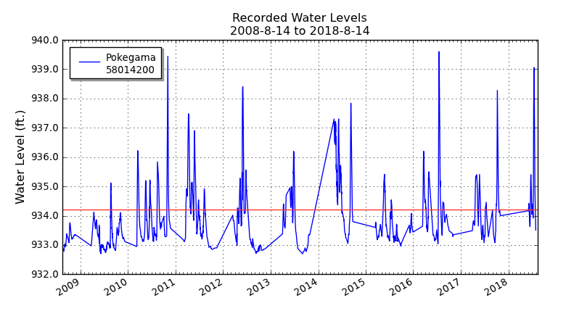

Recorded Range of One Other Great Lake of the World

The water level of Lake Baikal, Russia, fluctuated 3.9 feet from 2008-2018.
Data accessed through USDA.

Prepared by Minnesota Sea Grant, Sharon Moen and Tom Beery, 2019

